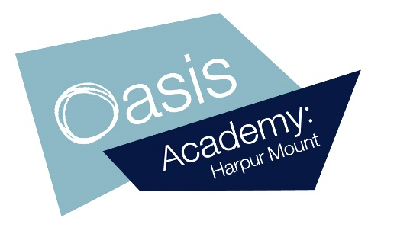

22.10.21
Dear Parents,
Returning to school after half-term
Thank you to everyone after a successful first half-term of the year. Pupils have settled well after the summer break, and I hope they get a chance to relax during the half-term holiday. I am writing to you about our return to school on Monday 1st November.
As you may know the number of confirmed Covid-19 cases across the country is rising. Therefore, we must continue to follow the precautions we have in place carefully. By taking care now, we reduce the risk of Covid-19 spreading in the school and the necessity to increase precautions or return to remote learning.
On the first day of the new half-term, before coming to school, please ensure your child is well, and has not:
- Got a high temperature, or
- Got a new, continuous cough, or
- Lost their sense of smell or taste or it’s changed

If they have any of these symptoms, you must keep them at home and arrange a PCR test. If the result is positive, they will have to self-isolate. If they receive a negative result, they can return to school.
Over the next half-term we will continue with all of our existing precautions, including:

- We will wash our hands thoroughly and often.
- We will follow good hygiene around sneezing, using and then disposing tissues safely.
- We will have a thorough cleaning schedule with regular cleaning equipment and a focus on frequently touched areas.
- We will ensure that the school is well ventilated.
- Pupils and staff must not come to school if they have symptoms of Covid, have had a positive test, or are required to quarantine.
- Senior leaders will meet to assess the risk at school. If necessary and in consultation with Public Health England, we will make changes to our arrangements to increase precautions.
Please remember - your child must only come to school if they are well.
Thank you for your continued support with helping us to reduce the risk of infection and minimise disruption to learning.
We hope you all have a great week. We know the children are really enjoying using their iPad in school and hopefully they continue to do so over the holidays.

Yours sincerely,

Sally Herbert
Principal
Oasis Academy Harpur Mount

